**Peshawar:**

Cuningham Clock Tower

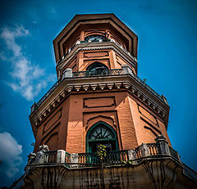

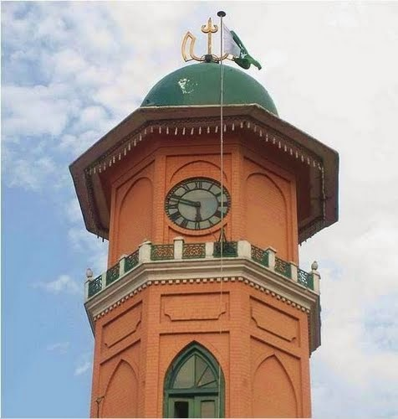

The **Cunningham Clock Tower** in Peshawar, Khyber-Pakhtunkhwa, Pakistan, was built in 1900, "in commemoration of the Diamond Jubilee of Her Majesty the Queen Empress". The tower was named after Sir George Cunningham, former British governor and political agent in the province. Designed by James Strachan, the Municipal Engineer of Peshawar, the foundation stone was laid by the George Cunningham, Governor of the North West Frontier Province (now Khyber Pakhtunkhwa) in 1898. It was opened to the public in 1900 to commemorate the Diamond Jubilee of Queen Victoria. The tower is 31 feet in diameter. Its base is 13 by 4 metres (43 ft × 13 ft) and stands 26 metres (85 ft) tall at the Ghanta Ghar Chowk (“Clock Tower Square”).